COMPUTERSCIENCE

PROJECT

BLACKJACK


PUNIT SHAH
XII-B
RollNo:120222
PSBB Sr. Sec. School

XII - B
PUNIT SHAH



ACKNOWLEDGEMENT

It would be appropriate to begin by expressing our gratitude to everyone that played a part in this project.

I would like to thank our computer science teacher Mrs. Kala Lakshmidass for guiding us through the lab work and for her valuable feedback, exemplary guidance, monitoring and endless inspiration throughout the making of our project.

We would also like to thank the school for providing us with the opportunity to encourage interest in computer science.

INDEX

•Introduction 5

•Flowchart 6

•Algorithm 9

•Project Code 19

•Output 41

•Scope For Improvement 42

•Limitations 42

•Bibliography 43

INTRODUCTION

- This C++ program is to play the classic casino game blackjack. In this program the dealer will be the computer and the player will be the user
- The objective of the game is to beat the dealer. If your cards total higher than the dealer's cards without going over 21 you win.
- In order to implement this we have chosen C++ as our programming language.
- This project includes binary file handling and the feature of betting in the game with the user’s money in his/her account which would then be saved and the user could play through the same account later

FLOW CHART
Function master( )

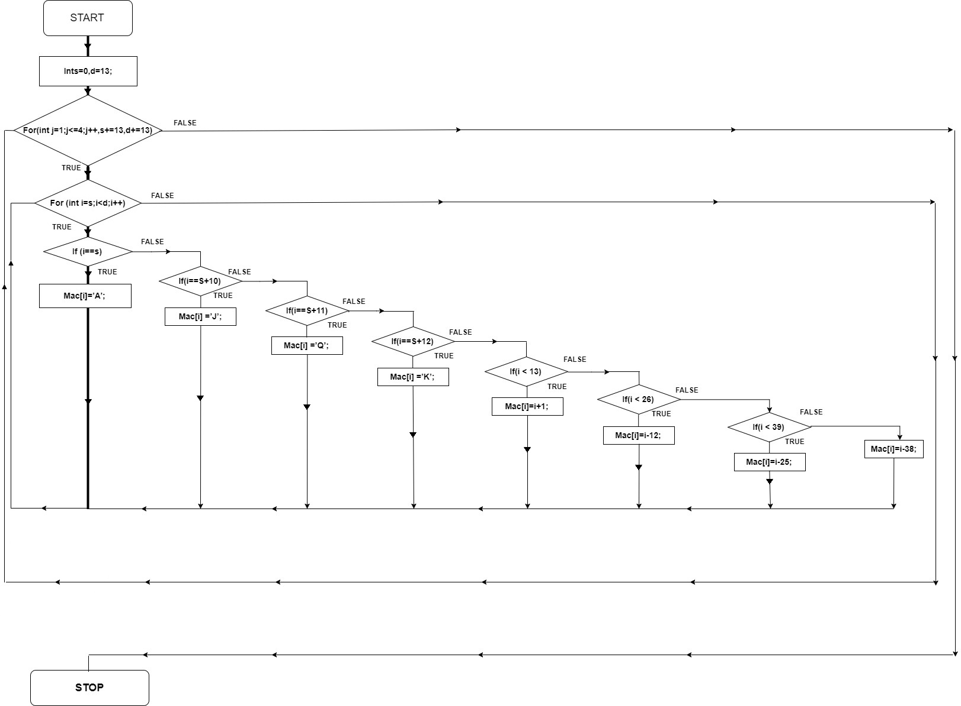

Function hit( )

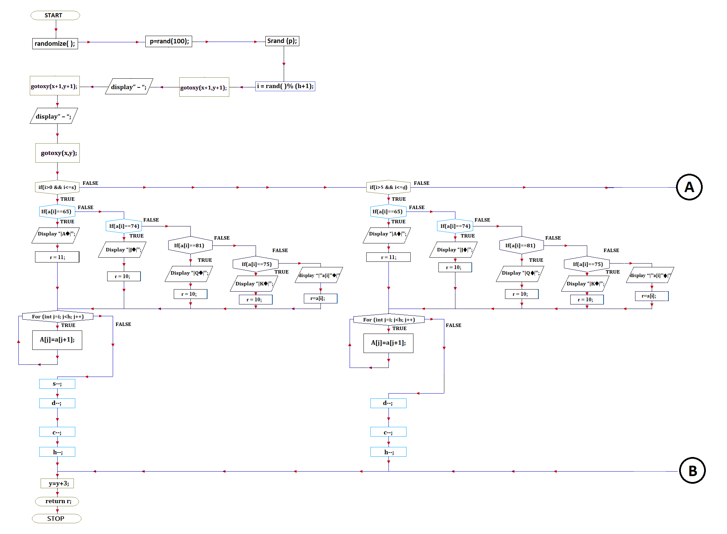

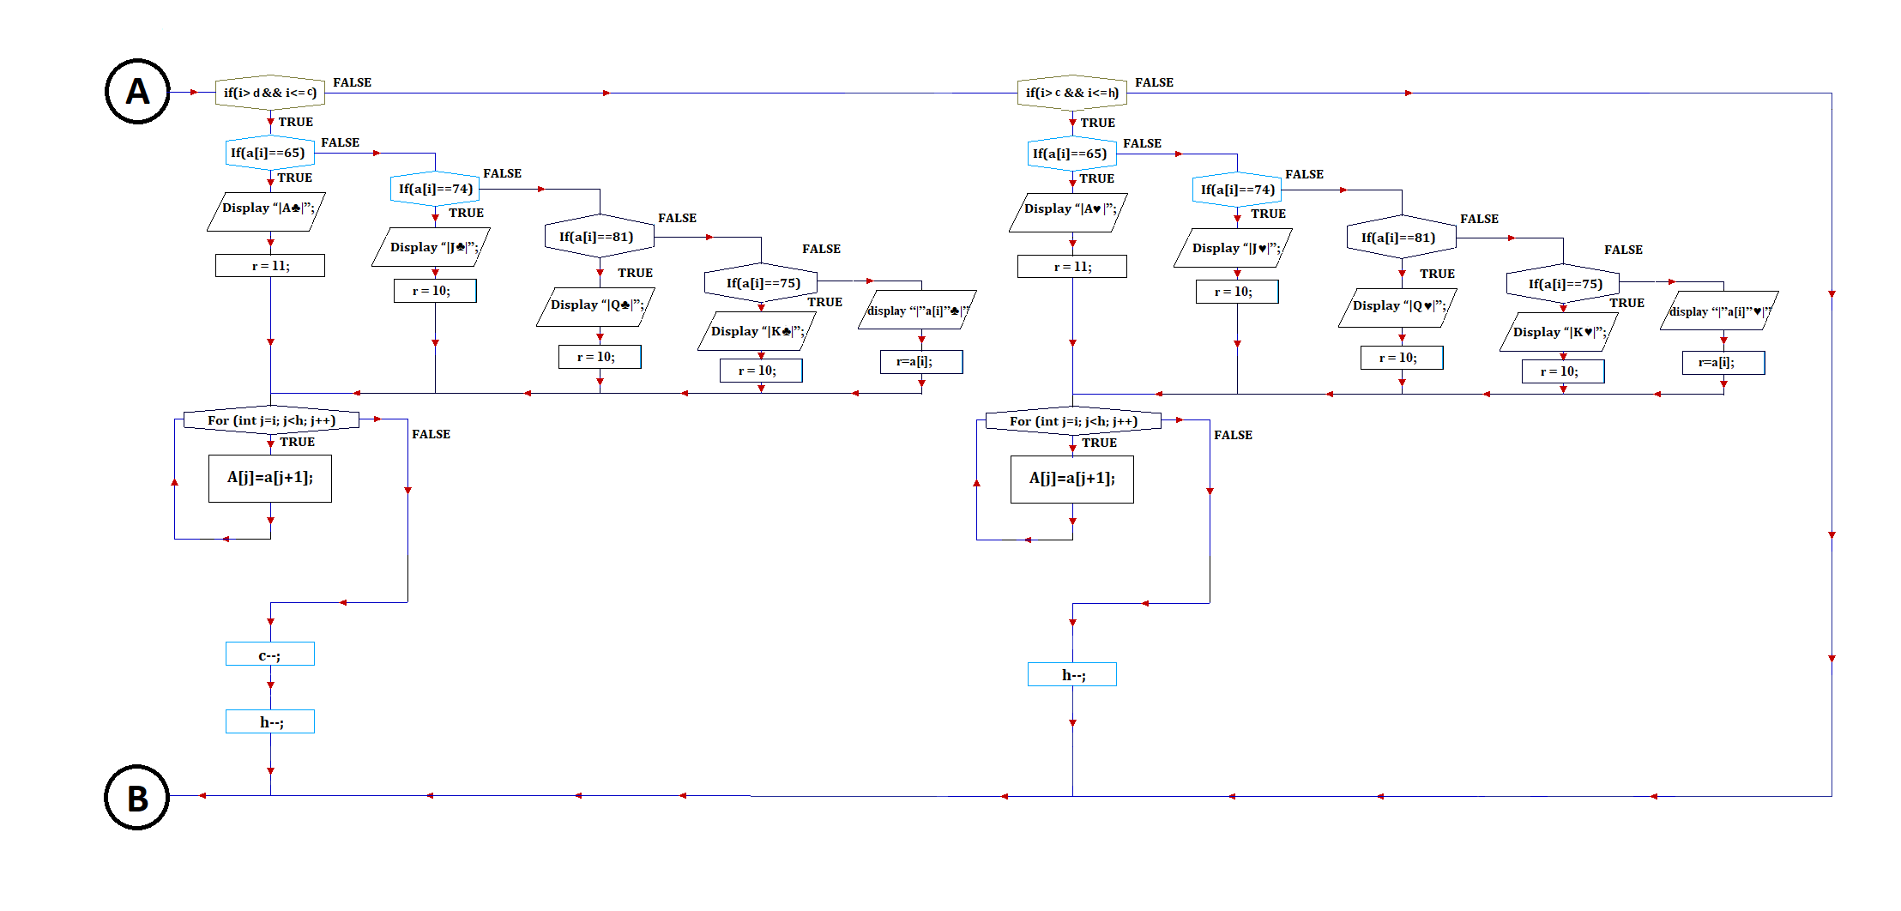

ALGORITHM
Declare the following global variables:
Char o and array username[40]
Int array mac[52]
Long int money=0

Function void master ():
- Start.
- Declare and initialize integer s and d to 0 and 13 respectively.
- Declare and initialize integer j to 1.
- Do steps 5 to 18 till j less than and equal to 4.
- Declare and initialize integer i to s.
- Do steps 7 to 16 till i less than d.
- If i=s, i of mac is assigned A
- Else if i=s+10,i of mac is assigned J
- Else if i=s+11,i of mac is assigned Q
- Else if i=s+12,i of mac is assigned K
- Else do steps 11 to 15
- If I less than 13,i of mac is assigned i+1
- Else if I less than 26,i of mac is assigned i-12
- Else if I less than 39,i of mac is assigned i-25
- Else ,i of mac is assigned i-38.
- Increment i by 1.
- s=s+13
- d=d+13
- Stop.
Function void newuser ():
- Start.
- Open an output file ‘BJUSER.dat’ in append and binary mode using the file stream f.
- If there is an error in opening the file, display ‘file not found’ and exit the function.
- Declare character arrays u[40],uc[40],p[40],pc[40],pj[40].
- Declare long integers mj and c.
- Initialize c to 0.
- Open an input file ‘BJUSER.dat’ in ‘in’ and ‘binary’ mode using the file stream g.
- If there is an error in opening the file, display ‘file not opened’ and exit the function.
- Clear the output screen
- Read in the username from user and store it in u.
- Declare and initialize integers i and flag to 0 and 1 respectively.
- Do steps 13 to17 till flag not equal to 0.
- Get a character from user and store it in i of p.
- Display ‘*’.
- If i of p =13, remove a character from display and decrement i by 1 and initialize flag to 0.
- Else if i of p=8, remove 2 character from display and decrement I by 1 two times.
- Increment i by 1.
- i-1 of p is assigned ‘\0’.
- Initialize i and flag to 0 and 1 respectively
- Do steps 21 to 25 till flag not equal to 0.
- Get a character from user and store it in i of pc.
- Display ‘*’.
- If i of pc =13, remove a character from display and decrement i by 1 and initialize flag to 0.
- Else if i of pc =8, remove 2 character from display and decrement I by 1 two times.
- Increment i by 1.
- i-1 of pc is assigned ‘\0’.
- if p and pc are not lexicographically the same then increment c by 1 and display “Please enter the correct Password”.
- Else do step 29 to 34
- Read in a username from ‘g’ and store it in uc.
- Do steps 31 to 34 till end of file is reached.
- Read in a password from ‘g’ and store it in pj.
- Read in money from ‘g’ and store it in mj.
- If uc and u are lexicographically the same then increment c by 1 and display “The username already exists.”
- Read in a username from ‘g’ and store it in uc.
- Close the file opened by g.
- Do steps 6 to 35 till c not equal to 0.
- Initialize mj to 100000.
- Write in a username ‘u’ into the file opened by ‘f’
- Write in a password ‘p’ into the file opened by ‘f’
- Write in a money ‘mj’ into the file opened by ‘f’
- Global variable money=mj.
- Close file opened by f.
- Copy the string u into global variable username.
- Stop.
Function void check ():
- Start
- Declare character array u[40],uc[40],p[40],pc[40].
- Declare long integers m and c.
- Open an input file ‘BJUSER.dat’ in ‘in’ and ‘binary’ mode using the file stream g.
- If there is an error in opening the file, display ‘file not opened’ and exit the function.
- Clear the output screen
- Read in the username from user and store it in u.
- Declare and initialize integers i and flag to 0 and 1 respectively.
- Do steps 10 to 114 till flag not equal to 0.
- Get a character from user and store it in i of p.
- Display ‘*’.
- If i of p =13, remove a character from display and decrement i by 1 and initialize flag to 0.
- Else if i of p=8, remove 2 character from display and decrement I by 1 two times.
- Increment i by 1.
- i-1 of p is assigned ‘\0’.
- Read in a username from ‘g’ and store it in uc.
- Do steps 18 to 26 till end of file is reached.
- Read in a password from ‘g’ and store it in pc.
- Read in money from ‘g’ and store it in mj.
- If uc and u are lexicographically the same and p and pc are lexicographically the same then do steps 21 to 24
- Copy the string u into global variable username
- Global variable money=m.
- Initialize c to 0
- Break out of the loop.
- Else increment c by 1.
- Read in a username from ‘g’ and store it in uc.
- Close the file opened by g.
- Do steps 4 to 27 till c not equal to 0.
- Stop.
Function void monupdate ():
- Open a file ‘BJUSER.dat’ in ‘in’, ‘out’ and ‘binary’ mode using the file stream f.
- If there is an error in opening the file, display ‘error’ and exit the function.
- Create a structure of the type player with members character array uc[40] and p[40],long integer m.
- Declare and object obj of the type player.
- Read in a record of a player from ‘f’ and store it in obj.
- Do steps 7 to 11 till end of file is reached.
- if username and uc of obj are lexicographically the same then do steps 8 to 10.
- Initialize money to m of obj.
- F.seekg(f.tellg()-sizeof(obj));
- Write in a record of a player ‘obj’ into the file opened by ‘f’
- Read in a record of a player from ‘f’ and store it in obj.
- Close the file opened by f.
- Stop

Function int hit (inta[],intx,int&y,int&s,int&d,int&c,int&h):
- Start.
- Declare integer i,r and p.
- Call the randomize function.
- P is assigned a value randomly from the numbers 0-9999
- Call srand function by passing p as a paraameter.
- Initialize i to remainder of number generated by rand() divided by h+1.
- Display “ –“ above and below y i.e. at (x+1,y-1) and (x+1,y+1)
- If i>0 and i less than and equal to s, then do steps 7 to 16.
- If i of a equal to 65, display”|A♠|”and initialize r to 11.
- Else if i of a equal to 74, display”|J♠|”and initialize r to 10.
- Else if i of a equal to 81, display”|Q♠|”and initialize r to 10.
- Else if i of a equal to 75, display”|K♠|”and initialize r to 10.
- Else display”| ‘a[i]’♠|”and initialize r to i of a.
- Declare and initialize j to i
- do steps 14 and 15 till j<h
- Initialize j+1of a to j of a.
- increment j by 1
- decrement s, d, c, h by 1
- Else if i>s and i less than and equal to d, then do steps 18 to 27.
- If i of a equal to 65, display”|A♦|”and initialize r to 11.
- Else if i of a equal to 74, display”|J♦|”and initialize r to 10.
- Else if i of a equal to 81, display”|Q♦|”and initialize r to 10.
- Else if i of a equal to 75, display”|K♦|”and initialize r to 10.
- Else display”| ‘a[i]’♦|”and initialize r to i of a.
- Declare and initialize j to i
- do steps 25 and 26 till j<h
- Initialize j+1of a to j of a.
- increment j by 1
- decrement d, c, h by 1
- Else if i>d and i less than and equal to c, then do steps 29 to 38.
- If i of a equal to 65, display”|A♣|”and initialize r to 11.
- Else if i of a equal to 74, display”|J♣|”and initialize r to 10.
- Else if i of a equal to 81, display”|Q♣|”and initialize r to 10.
- Else if i of a equal to 75, display”|K♣|”and initialize r to 10.
- Else display”| ‘a[i]’♣|”and initialize r to i of a.
- Declare and initialize j to i
- do steps 36 and 37 till j<h
- Initialize j+1of a to j of a.
- increment j by 1
- decrement c, h by 1
- Else if i>c and i less than and equal to h, then do steps 40 to 49.
- If i of a equal to 65, display”|A♥|”and initialize r to 11.
- Else if i of a equal to 74, display”|J♥|”and initialize r to 10.
- Else if i of a equal to 81, display”|Q♥|”and initialize r to 10.
- Else if i of a equal to 75, display”|K♥|”and initialize r to 10.
- Else display”| ‘a[i]’♥|”and initialize r to i of a.
- Declare and initialize j to i
- do steps 47 and 48 till j<h
- Initialize j+1of a to j of a.
- increment j by 1
- decrement h by 1
- Add 3 to the value of y.
- Return the value of r.
- Stop.
Algorithm for void main
1.START
2.invoke function master()
3.declare character variables a and r
4.read in ‘n’ or ‘o’ if the user is a new or old user into a
5.if a=’n’ or a=’N’ invoke function newuser()
6.else if a=’o’ or a=’O’ invoke function check()
7.declare integer array card of size 52 and integer variables u,de,yu,yd
8.declare character variable ch=0
9.read in the option from the user into r to read the rules
10.if r=’R’ or r=’r’ display the rules
11.displayusername
12.declare integer arrays su and sd of size 20 and integer variables sup=0 and
sdp=0
13.initialise u=de=0
14.initialise integer variable i=0
15.repeatsteps 16 and 17 till i<52
16.assigni of mac to i of card
17.incrementi by 1
18.declare integer variables s=12,d=25,c=38,h=51 and x
19.assignyu=yd=6
20 .read in the amount to bet into bet
21.if bet<=money and bet not equal to 0 do steps 22 to 89
22.display username
23.displaymoney
24.assign x to the value returned by the function hit by passing
card,10,yu,s,d,c,h as parameters
25. increment u by x
26.assign x to sup of su
27. increment sup by 1
28. display “sum=” and u
29.assign x to the value returned by the function hit by passing
card,65,yd,s,d,c,h as parameters
30.increment de by x
31.assign x to sdp of sd
32.incrementsdp by 1
33.display “sum=” and de
34.assign x to the value returned by the function hit by passing
card,10,yu,s,d,c,h as parameters
35.assign x to sup of su
36.increment sup by 1
37.if x=11 and u=11 do step 38
38.increment u by 1 and assign 1 to (sup-1) of su and display “sum=” and u
39.elseincrement u by x and display sum
40.if u=21 display black jack and assign ch to ‘s’
41.else do steps 42 to60
42.declare integers ct=0 and p
43.read in the option if the user wants to hit or stand into ch
44.if ch=’h’ do steps 45 to 59
45.assign x to the value returned by the function hit by passing
card,10,yu,s,d,c,h as parameters
46.increment u by x
47.assign x to sup of su
48.increment sup by 1
49.declare integer z=0;
50.repeatsteps 51 and 52 till z<sup
51. if z of su is equal to 11 increment ct by 1 and assign z to p
52. increment z by 1
53. if x=11 and u>21 do step 54
54. decrement u by 10 and assign 1 to (sup-1) of su and display “sum=” and u
55. else if u=21 display black jack and sum u assign ch to ‘s’
56.else if u>21 and ct not equal to 0 do step 57
57.decrement u by 10 and assign p of su to 1 and display sum u
58.else if u>21 display “busted” and sum u and assign ch to ‘s’ and assign u to
zero
59.else display “sum” and u
60.else if ch not equal to ‘s’ display wrong option
61.repeatsteps 40 to 60 till ch not equal to ‘s’
62.declare integers ct=0 and p
63.assign x to the value returned by the function hit by passing
card,65,yd,s,d,c,h as parameters
64.assign x to sdp of sd
65.incrementsdp by 1
66.if x=11 and de=11 do steps 67
67.increment de by 1 and assign 1 to (sdp-1) of sd and display “sum=” and de
68.else increment de by x and display sum
69.if u not equal to zero do step 70
70.repeatsteps 71 to 86 till de<17 and de not equal to zero
71.declare integers ct=0 and p=0
72.assign x to the value returned by the function hit by passing
card,65,yd,s,d,c,h as parameters
73.increment de by x
74.assign x to sdp of sd
75.incrementsdp by 1
76.declare integer z=0;
77.repeatsteps 78 and 79 till z<sdp
78.if z of sd is equal to 11 increment ct by 1 and assign z to p
79.increment z by 1
80.if x=11 and de>21 do step 81
81.decrement de by 10 and assign 1 to (sdp-1) of sd and display “sum=” and
de
82.else if de=21 display black jack and sum de
83.else if de>21 and ct not equal to 0 do step 84
84.decrement de by 10 and assign p of sd to 1 and display sum de
85.else if de>21 display “busted” and sum de and assign de to 0
86.else display “sum” and de
87.if u>de display “you won “ and money=money+bet
88.else if u<de display “you lost” and money=money-bet
89.else display “it’s a draw”
90.else if bet>money or bet=0 display “bet invalid”
91.assign o=’p’
92.repeatsteps 93 and 94 till o not equal to ‘y’,’Y’,’n’ or ‘N’
93.read in the option if the user wants to continue playing or not into o
94.if o not equal to ‘y’,’Y’,’n’ or ‘N’ display invalid option
95.repeatsteps 11 to 94 till o=’y’ or o=’Y’
96.invoke function monoupdat() and display “thank you for playing”

PROJECT CODE
#include<iostream.h>
#include<fstream.h>
#include<conio.h>
#include<string.h>
#include<stdio.h>
#include<stdlib.h>
char username[40]={'\0'},o;
int mac[52]={0};
longint money=0;
void master()
{
int s=0,d=13;
for(int j=1;j<=4;j++,s+=13,d+=13)
{
for(inti=s;i<d;i++)
{
if(i==s)
mac[i]='A';
else if(i==s+10)
mac[i]='J';
else if(i==s+11)
mac[i]='Q';
else if(i==s+12)
mac[i]='K';
else
{
if(i<13)
mac[i]=i+1;
else if(i<26)
mac[i]=i-12;
else if(i<39)
mac[i]=i-25;
else
mac[i]=i-38;
}
}
}
}

voidnewuser()
{
ofstream f("C:/TURBOC3/BIN/BJUSER.dat",ios::app|ios::binary);
if(!f)
{
cout<<"file not opened "<<endl;return;
}
char u[40],uc[40],p[40],pc[40],pj[40];
longintmj,c;
do
{
c=0;
ifstream g("C:/TURBOC3/BIN/BJUSER.dat",ios::in|ios::binary);
if(!g)
{
cout<<"file not opened "<<endl;return;
}
clrscr();
cout<<"ENTER NEW USERNAME : ";
gets(u);
cout<<"ENTER PASSWORD : ";
inti=0, flag=1;
while(flag)
{
p[i]=getch();
cout<<"*";
if(p[i]==13)
{
flag=0;
cout<<"\b \b";
}
else if(p[i]==8)
{
cout<<"\b\b \b\b";
i--;
i--;
}
i++;
}
p[i-1]='\0';
cout<<endl<<"RE-ENTER THE SAME PASSWORD TO CHECK : ";
i=0;
flag=1;
while(flag)
{
pc[i]=getch();
cout<<"*";
if(pc[i]==13)
{
flag=0;
cout<<"\b \b";
}
else if(p[i]==8)
{
cout<<"\b\b \b\b";
i--;
i--;
}
i++;
}
pc[i-1]='\0';
if(strcmpi(pc,p)!=0)
{
c++;cout<<"please enter the correct password";
}
else
{
for(g.read((char*)&uc,sizeof(uc));!g.eof();g.read((char*)&uc,sizeof(uc)))
{
g.read((char*)&pj,sizeof(pj));
g.read((char*)&mj,sizeof(mj));
if(strcmpi(uc,u)==0)
{
c++;cout<<"the username already exists";
}
}
}
g.close();
}
while(c);
mj=100000;
f.write((char*)&u,sizeof(u));
f.write((char*)&p,sizeof(p));
f.write((char*)&mj,sizeof(mj));
money=mj;
f.close();
strcpy(username,u);
}

void check()
{
char u[40],uc[40],p[40],pc[40];
longintm,c;
do
{
ifstream g("C:/TURBOC3/BIN/BJUSER.dat",ios::in|ios::binary);
clrscr();
cout<<"ENTER USERNAME : ";
gets(u);
cout<<"ENTER PASSWORD : ";
inti=0,flag=1;
while(flag)
{
p[i]=getch();
cout<<"*";
if(p[i]==13)
{
flag=0;
cout<<"\b \b";
}
else if(p[i]==8)
{
cout<<"\b\b \b\b";
i--;
i--;
}
i++;
}
p[i-1]='\0';
for(g.read((char*)&uc,sizeof(uc));!g.eof();g.read((char*)&uc,sizeof(uc)))
{
g.read((char*)&pc,sizeof(pc));
g.read((char*)&m,sizeof(m));
if(strcmpi(uc,u)==0&&strcmpi(p,pc)==0)
{
strcpy(username,u);money=m;
cout<<endl<<"successful...";
c=0;
break;
}
else
c++;
}
g.close();
}
while(c);
getch();
}

voidmonupdat()
{
fstream f("C:/TURBOC3/BIN/BJUSER.dat",ios::in|ios::out|ios::binary);
if(!f)
{
cout<<"error ";return;
}
struct player
{
charuc[40],p[40];long int m;
}
obj;
f.read((char*)&obj,sizeof(obj));
while(!f.eof())
{
if(strcmpi(username,obj.uc)==0)
{
obj.m=money;
f.seekg(f.tellg()-sizeof(obj));
f.write((char*)&obj,sizeof(obj));
}
f.read((char*)&obj,sizeof(obj));
}
f.close();
}

int hit(int a[],intx,int&y,int&s,int&d,int&c,int&h)
{
inti,r,p;
randomize();
p=random(10000);
srand(p);
i=rand()%(h+1);
gotoxy(x+1,y-1);
cout<<" --" ;
gotoxy(x+1,y+1);
cout<<" --" ;
gotoxy(x,y);
if(i>=0&&i<=s)
{
if(a[i]==65)
{
cout<<" |A\6| ";
r=11;
}
else if(a[i]==74)
{
cout<<" |J\6| ";
r=10;
}
else if(a[i]==81)
{
cout<<" |Q\6| ";
r=10;
}
else if(a[i]==75)
{
cout<<" |K\6| ";
r=10;
}
else
{
cout<<" |"<<a[i]<<"\6| ";
r=a[i];
}
for(int j=i;j<h;j++)
a[j]=a[j+1];
s--;d--;c--;h--;
}
else if(i>s&&i<=d)
{
if(a[i]==65)
{
cout<<" |A\4| ";
r=11;
}
else if(a[i]==74)
{
cout<<" |J\4| ";
r=10;
}
else if(a[i]==81)
{
cout<<" |Q\4| ";
r=10;
}
else if(a[i]==75)
{
cout<<" |K\4| ";
r=10;
}
else
{
cout<<" |"<<a[i]<<"\4| ";
r=a[i];
}
for(int j=i;j<h;j++)
a[j]=a[j+1];
d--;c--;h--;
}
else if(i>d&&i<=c)
{
if(a[i]==65)
{
cout<<" |A\5| ";
r=11;
}
else if(a[i]==74)
{
cout<<" |J\5| ";
r=10;
}
else if(a[i]==81)
{
cout<<" |Q\5| ";
r=10;
}
else if(a[i]==75)
{
cout<<" |K\5| ";
r=10;
}
else
{
cout<<" |"<<a[i]<<"\5| ";
r=a[i];
}
for(int j=i;j<h;j++)
a[j]=a[j+1];
c--;h--;
}
else if(i>c&&i<=h)
{
if(a[i]==65)
{
cout<<" |A\3| ";
r=11;
}
else if(a[i]==74)
{
cout<<" |J\3| ";
r=10;
}
else if(a[i]==81)
{
cout<<" |Q\3| ";
r=10;
}
else if(a[i]==75)
{
cout<<" |K\3| ";
r=10;
}
else
{
cout<<" |"<<a[i]<<"\3| ";
r=a[i];
}
for(int j=i;j<h;j++)
a[j]=a[j+1];
h--;
}
y+=3;
return r;
}

void main()
{
clrscr();
master();
char a,r;
cout<<"enter n if new user and enter o if old user ";
cin>>a;
if(a=='n' || a==’N’)
newuser();
else if(a=='o' || a==’O’)
check();
int card[52],u,de,yu,yd;
long int bet;
char ch=0;
clrscr();
cout<<"enter R to see rules and any other key to play the GAME "<<endl;
cin>>r;
if(r=='r'||r=='R')
{
cout<<"RULES"<<endl;
cout<<"OBJECT OF THE GAME"<<endl<<"player attempts to beat the dealer by getting a count as close to 21 as possible, without going over 21."<<endl;
cout<<"CARD VALUES/SCORING"<<endl<<"It is up to the player if an ace is worth 1 or 11. Face cards are 10 and any other card is its pip value."<<endl;
cout<<"BETTING"<<endl<<"Before the deal begins, the player places a bet, in front of him in the designated area."<<endl;
cout<<"THE PLAY"<<endl<<"The player to goes first and must decide whether to \"stand\" (not ask for another card) or \"hit\" (ask for another card in an attempt to get closer to a count of 21, or even hit 21 exactly). Thus, a player may stand on the two cards originally dealt him, or he may ask the dealer for additional cards, one at a time, until he either decides to stand on the total (if it is 21 or under), or goes \"bust\" (if it is over 21)"<<endl;
}
getch();
do
{
clrscr();
cout<<"welcome to BLACK JACK "<<endl;
puts(username);
gotoxy(1+strlen(username),2);
cout<<": "<<money;
intsu[20],sd[20],sup=0,sdp=0;
u=de=0;
for(inti=0;i<52;i++)
card[i]=mac[i];
int s=12,d=25,c=38,h=51,x;
yu=yd=6;
cout<<endl<<"enter amount to bet : ";
cin>>bet;
if(bet<=money && bet!=0)
{
gotoxy(10,4);
puts(username);
gotoxy(11+strlen(username),4);
cout<<": "<<money;
gotoxy(65,4);
cout<<"dealer";
x=hit(card,10,yu,s,d,c,h);
u+=x;
su[sup++]=x;
gotoxy(10,25);
cout<<"sum = "<<u;
x=hit(card,65,yd,s,d,c,h);
de+=x;
sd[sdp++]=x;
gotoxy(65,25);
cout<<"sum = "<<de;
x=hit(card,10,yu,s,d,c,h);
su[sup++]=x;
if(x==11&&u==11)
{
u++;
gotoxy(10,25);
cout<<"sum = "<<u;
}
else
{
u+=x;
gotoxy(10,25);
cout<<"sum = "<<u;
}
do
{
if(u==21)
{
gotoxy(10,23);
cout<<"BLACK JACK"<<endl;
gotoxy(10,25);
cout<<"sum = "<<u;
ch='s';
}
else
{
intct=0,p;
gotoxy(10,24);
cout<<"enter 'h' to hit or 's' stand : ";
cin>>ch;
if(ch=='h')
{
x=hit(card,10,yu,s,d,c,h);
u+=x;
su[sup++]=x;
for(int z=0;z<sup;z++)
if(su[z]==11)
{
ct++;p=z;
}
if(x==11&&u>21)
{
u-=10;
su[sup-1]=1;
gotoxy(10,25);
cout<<"sum = "<<u;
}
else if(u==21)
{
gotoxy(10,23);
cout<<"BLACK JACK"<<endl;
gotoxy(10,25);
cout<<"sum = "<<u;
ch='s';
}
else if(u>21&&ct!=0)
{
u=u-10;su[p]=1;
gotoxy(10,25);
cout<<"sum = "<<u;}
else if(u>21)
{
gotoxy(10,23);
cout<<"BUSTED"<<endl;
gotoxy(10,25);
cout<<"sum = "<<u;
ch='s';
u=0;
}
else
{
gotoxy(10,25);
cout<<"sum = "<<u;
}
}
else if(ch!='s')
{
gotoxy(10,26);
cout<<"wrong option ";
}
}
}
while(ch!='s');
intct=0,p;
x=hit(card,65,yd,s,d,c,h);
sd[sdp++]=x;
if(x==11&&de==11)
{
sd[sdp-1]=1;
de++;
gotoxy(65,25);
cout<<"sum = "<<de;
}
else
{
de+=x;
gotoxy(65,25);
cout<<"sum = "<<de;
if(de==21)
{ gotoxy(65,24);
cout<<"BLACK JACK";
}
if(u!=0)
{
while(de<17&&de!=0)
{
intct=0,p=0;
x=hit(card,65,yd,s,d,c,h);
de+=x;
sd[sdp++]=x;
for(int z=0;z<sdp;z++)
if(sd[z]==11)
{
ct++;p=z;
}
if(x==11&&de>21)
{
de-=10;
sd[sdp-1]=1;
gotoxy(65,25);
cout<<"sum = "<<de;
}
else if(de==21)
{
gotoxy(65,25);
cout<<"sum = "<<de;
gotoxy(65,23);
cout<<"BLACK JACK"<<endl;
}
else if(de>21&&ct!=0)
{
de=de-10;sd[p]=1;
gotoxy(65,25);
cout<<"sum = "<<de;}
else if(de>21)
{
gotoxy(65,23);
cout<<"BUSTED"<<endl;
gotoxy(65,25);
cout<<"sum = "<<de;
de=0;
}
else
{
gotoxy(65,25);
cout<<"sum = "<<de;
}
}
}
if(u>de)
{
cout<<endl<<"you won!!!!";
money+=bet;
}
else if(u<de)
{
cout<<endl<<" you lost -:' ";
money-=bet;
}
else
cout<<endl<<"It's a Draw";
}
else if(bet>money || bet==0)
{
cout<<endl<<"bet invalid:don't have money ";
}
o='p';
while(o!='y' && o!='Y'&& o!='n' && o!='N')
{
cout<<endl<<"enter 'y' to continue playing and 'n' to exit ";
cin>>o;
if(o!='y' && o!='Y'&& o!='n'&& o!='N')
cout<<"invalid opion"<<endl;
}
}
while(o=='y' || o=='Y');
monupdat();
cout<<endl<<" THANK YOU FOR PLAYING "<<username<<" "<<endl<< “ YOUR BALANCE IS : “<<money;
getch();
}

OUTPUT
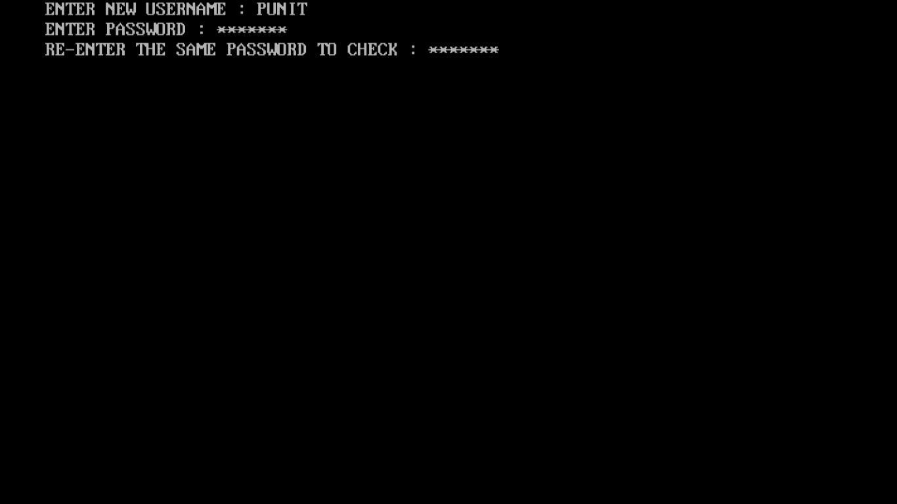

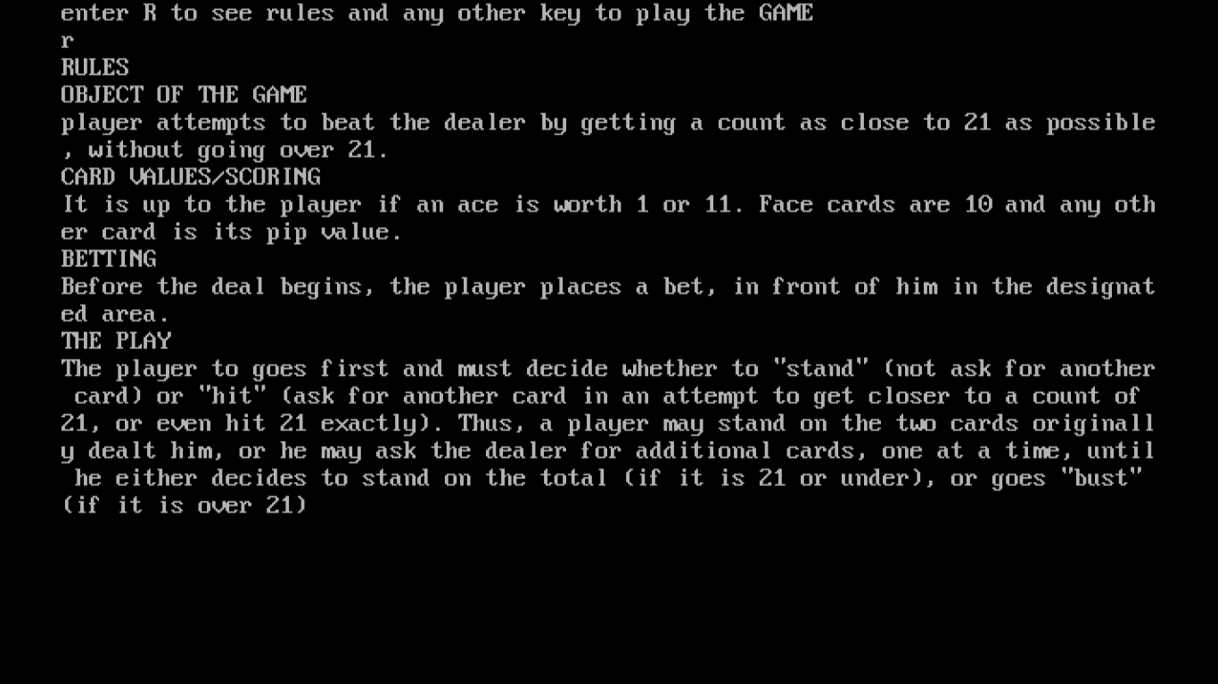

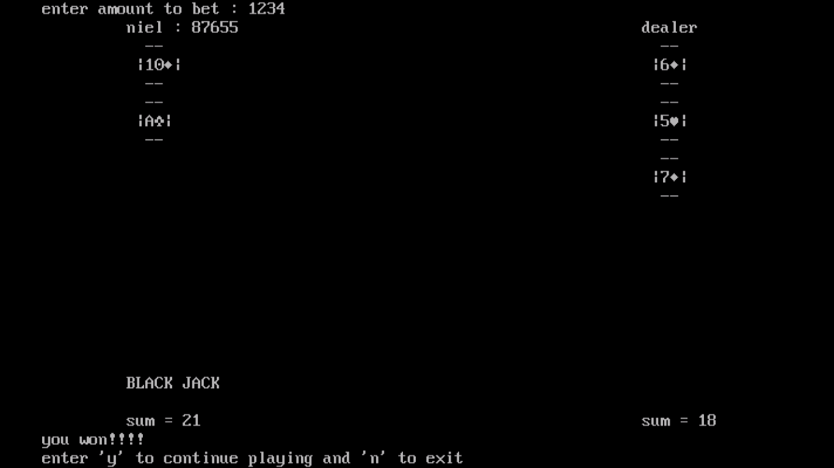

LIMITATIONS

- The game is limited to only one player
- The existing system only provides text base interface , which is not as user friendly as graphical user interface
- Unlike the standard blackjack game played at a casino, where after one game the cards already used are flushed(not used in the next game) our program shuffles the same deck including the used cards which is used to play the next game

SCOPE FOR IMPROVEMENT

- Use graphics to display the cards and make the game more user friendly
- Use the same deck to play the following game until the cards don’t get over
- The game can include 2 or more players to make the game more like a game played in the real world

BIBLIOGRAPHY

- Turbo C help Index
- Sumitraarora class 12 and 11.
- BLACK JACK RULES wikipedia

